

Ben-Gurion University of the Negev

Faculty of Engineering Science

School of Electrical and Computer Engineering

Dept. of Electrical Engineering

Finals Year Engineering Project

PDR

Unmanned Surface Vehicle for Searching and Survey of shallow water bodies

|  |  |
| --- | --- |
| **p-2023-115** | **Project ID** |
| **Yuval Avigdor – 203387097**  **avigdory@post.bgu.ac.il**  **Yonatan Axelrad – 311366249**  **axelray@post.bgu.ac.il** | **Students** |
| **Hugo Guterman** | **Supervisor** |
| - | **Sponsors** |
| **25.11.2022** | **Submission date** |

**Unmanned Surface Vehicle for Searching and Survey of shallow water bodies**

Authors: Yuval Avigdor (avigdory@post.bgu.ac.il), Yonatan Axelrad ([axelray@post.bgu.ac.il](mailto:axelray@post.bgu.ac.il))

Adviser's name: Prof Guterman Hugo.

**Key words**: Side scan sonar, ASV, AUV, Seabed, Real-time communication.

**Abstract:**

Of all the different types of water reservoirs, this project will focus mainly on shallow water bodies (*e.g. small lakes, fish pools, drinking water reservoirs etc.).* It is important to keep in mind the fact that many of these bodies of water are known to have interference factors like water pumps and muddy waters.

Over the last decade, more and more people are realizing the need in surveying the seabed of these bodies of waters, both for ecological research and also police matters such as recovering human bodies thrown in.

The project aims to implement a design that can be rapidly deployed in the field and that can navigate its way in shallow water reservoirs. Using different sensors, the system will give the users a better understanding of what the area underwater looks like and even where certain objects are.

Solutions offered today mostly make use of AUV (Autonomous Underwater Vehicles) that mainly send information to the user at the end of the run, due to limited bandwidths of acoustic modems.

The solution proposed in this project is instead an autonomous Kayak-based ASV (Above Surface Vehicle) that uses real-time communication to transmit data from sensors such as a side scan sonar, camera and GPS to an operator in a remote location. The platform will be implemented with a guidance system that would allow it to receive a pre-determined route and move by it.

Having real-time data will ensure that the platform doesn't waste time and power. With a real-time image, the operator could decide to end a mission if he sees the desired object, rather than waiting for the run to end and seeing what data the vehicle gathered. Moreover, an autonomous operation will cut expenses by reducing the need of human work force.

**תקציר**

מאגרי מים קיימים בהרבה צורות וגדלים, ועם סוגים שונים של מים. פרויקט זה יתמקד בעיקר על מאגרי מים רדודים, כמו מרינות ימיות, בריכות דגים או מאגרי מים לשתייה. כמובן שיש לקחת בחשבון שהרבה מגופי המים האלו מכילים הפרעות כמו מים בוציים או משאבות.

בשנים האחרונות הרבה חברות מנסות להשיג שיפור של היכולות לחיפוש תת מימי, ליכולות אלו שימושים רבים, לדוגמה:

1. מציאה והחזרה של ציוד וטכנולוגיה צבאית.
2. עזרה לכוחות הביטחון באיתור של גופות או עצמים שהוסתרו מתחת למים.
3. מיפוי של קרקעית הים במרינות לצורך שיט בטוח.

מטרת הפרויקט היא לשלב מספר מערכות וחיישנים על כלי שיט, לצורך ביצוע של מגוון משימות.  
הכלי יצטרך להיות מסוגל לנווט את עצמו לנק' ציון שנקבעו מראש ע"י המשתמש, בעזרת מידע בזמן אמת ממערכת ניווט לוויינית. הכלי יסרוק את הקרקעית תוך כדי תנועה והקלטה של המידע שנאסף. בפרויקט זה יעשה שימוש בעקרונות שפותחו עבור כלים אוטונומיים שתוכננו במיוחד עבור מאגרי מים.

הפתרונות שקיימים היום בתעשייה לרוב עושים שימוש במערכות תת מימיות אשר מקליטות את המידע ומעבירות אותו למשתמש רק בהגעה לחוף עם סיום המשימה, בעיקר בגלל בעיות של רוחב פס קטן בתקשורת תת ימית. חלק מהחברות עושות שימוש בכלים אוטונומיים תת מימיים [1] אשר דורשים בכבל פיזי לצרכי תקשורת שיוצר בעיות אחרות של מוגבלות בתנועה ומרחק.

הגישה המוצעת בפרויקט הוא שימוש בכלי על-מימי (קיאק) אשר יעשה שימוש בתקשורת זמן-אמת ויעביר מידע מכל החיישנים שלו כגון מערכת ניווט לוויינית, חיישן מגנטי, סונאר [2] ומצלמה. העברת המידע תעשה באמצעות אנטנת WIFI להעברת רוב המידע ובנוסף תקשורת LoRa [3] להעברת נתוני טלמטריה בסיסיים.

העברה של כל המידע למשתמש בזמן אמת תשפר את הסיכויים למשימה מוצלחת. במצבים שבהם המשתמש יכול לראות את המטרה בעין יחסך זמן רב על חיפוש המטרה והמשתמש יוכל לשלוח את הקיאק אל האובייקט ישירות. שילוב של שימוש בתקשורת זמן אמת ותכנון המסלול מראש יביא לדיוק גבוה יותר בסריקות וחיסכון בזמן שנדרש לבצע את הסריקות.

**Project goals:**

The primary goal of the project is to implement the autonomous guidance system that will allow the ASV to keep its route, as well as implementing monitor modules for all sensors used on the platform (e.g. Side scan sonar, Camera, Magnetometer, GPS etc.). The data collected from these sensors will be sent to a remote operator in real-time. This will enable the remote operator to detect desired objects, adjust the mission as needed while it is in progress, and make more efficient mission plans.

The main goal can be broken down into:

* Establishing full communication with all sensors and receiving a clear picture from the sonar.
* Implementing control modules for motors.
* Working with a mechanical engineering team to figure out the optimal positioning of both the motors and the sonar.
* Developing software (coding will be done in Python) that would integrate all modules and communicate between them. The communication between modules will be ROS2 based.

**Measure of success:**

The project will be considered successful under the following conditions:

1. A clear image can be transmitted by the sonar and received by a remote computer.
2. The platform can navigate itself by receiving target waypoints and a final run time.

At roughly 300 meters the expectation is that high-bandwidth data will be received, and at around 2 Kilometers, low-bandwidth data will be received.

**Specifications:**

The platform in this project is an autonomous Kayak-based ASV that does real-time seabed mapping. Movement of the ASV will be controlled by an implemented guidance algorithm that makes use of target waypoints and local positioning received via onboard GPS.

The main chamber will house the electronics involved in the project and will be mounted atop the Kayak. An UP ™ board computer will make use of the ROS2 system in order to handle communication between the sensors as well as controlling the motors.

Two cameras will be mounted on the platform – below and above water in order to give the user additional angles.

The Sonar which is placed in a sealed chamber will be mounted below the Kayak (pending sit down with mechanical team) and will have environmental sensors to monitor the status of the sealed chamber.

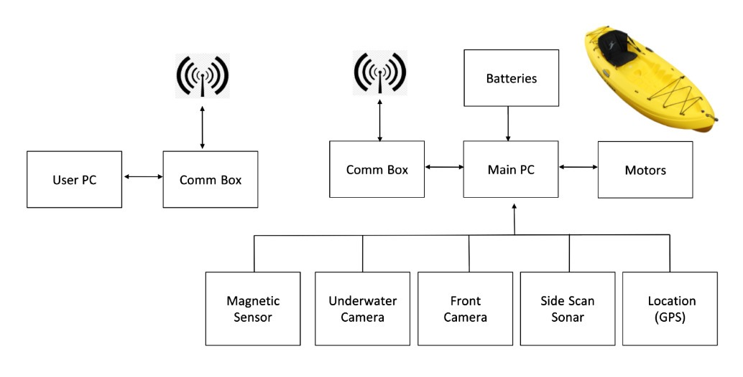

Figure 1 System schematic layout

* Batteries: the system will include two cells of lithium battery.
  + Voltage: 28.8V nominal.
  + Capacity: 49.5Ah.
  + Pack Power: 1425Wh.
* Motors: Two Torqeedo Ultralight 403A Pylon motors
  + Max. input power 400W
  + Max. propulsive power 180W
  + Total weight 8.8kg.
* Computer: UP Board series
  + Intel® ATOM™ x5-Z8350 Processors 64 bits up to 1.92GHz.
  + 4GB DDR3L RAM
  + 64GB eMMC.
  + 4x USB2.0 on connectors.
  + UART on header.
  + I2C on header.
* Cameras - Flea3-GE:
  + Front Camera: In order to define border limits (coastline).
  + Underwater Camera: Scan the area below the kayak to find to detect objects.
  + 1.3MP image.
  + 31FPS at 1288x694.
* Location: GPS sensor (NEO-M8N) for real time position and navigation system.
  + Update rate up to 10 Hz.
* Side Scan Sonar:  Klein UUV-3500, survey the underwater surface, (see figure 2).
  + Operation frequencies - 455 kHz, 900 kHz.
  + Beam width - horizontal: 0.34°, vertical: 45°.
  + Typical range - 150 m @ 455 kHz, 75 m @ 900 kHz.
  + Multibeam Bathymetry – 125 m nominal/side (typically 10 to 12 times altitude) @ 455 kHz.

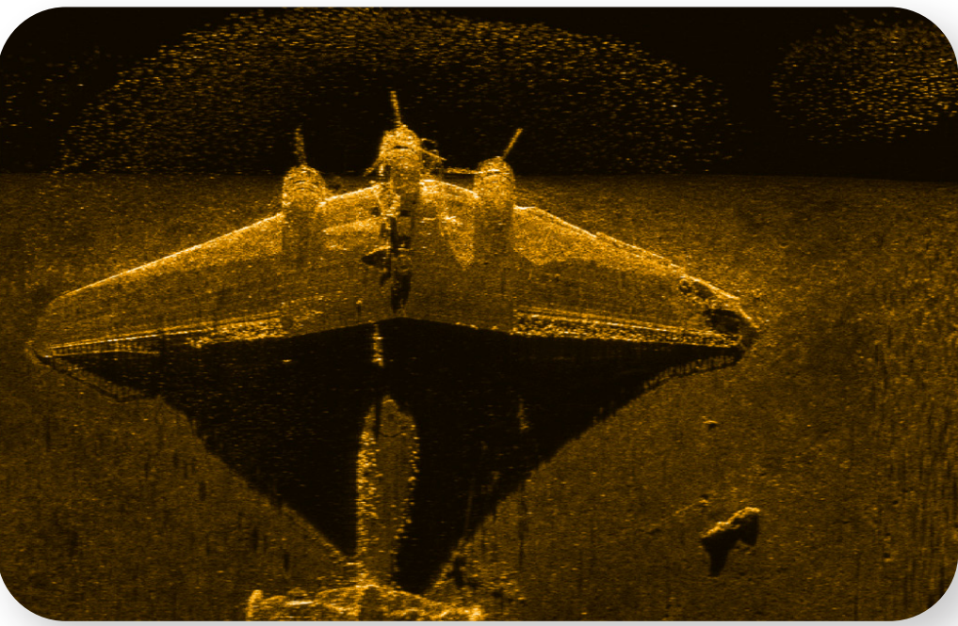

Figure 2 Taken by Side Scan Sonar (Klein uuv 3500)

* Communication Box - RF modems for transmitting data and telemetries between the kayak and the operator on shore:
  + WIFI - bit rate up to 150Mbps @ 2.4GHz.
  + Lora SX1276 - bit rate up to 1.4kbps @ 433MHz.
* Magnetic Sensor: Measure magnetic field beneath the kayak.
  + Operating range: 20000 to 100000 nT
  + Max sample rate: 20Hz

**Design proposal:**

The system has three main parts:

* Main chamber, which contains sensors and communications.
* Side-scan sonar chamber.
* Motors.

**Main chamber**: The main chamber will mounted on the platform, connected to a 28v battery. The chamber will be IP67 proof electricity box with the following design:

Figure Main chamber design

**The side-scan sonar chamber:** The side scan sonar transducers are located beneath the ASV as they must be below sea level to operate correctly. For maximum heat dissipation, and due to cable length limitations, the Sonar chamber will also be mounted below the ASV. The chamber is fully waterproof (up to depths of 300 meters) and all connectors and cables attached to it are also waterproof. The chamber is given an environmental sensor to monitor the pressure, humidity and temperature of the chamber to monitor the sealing level of the chamber.

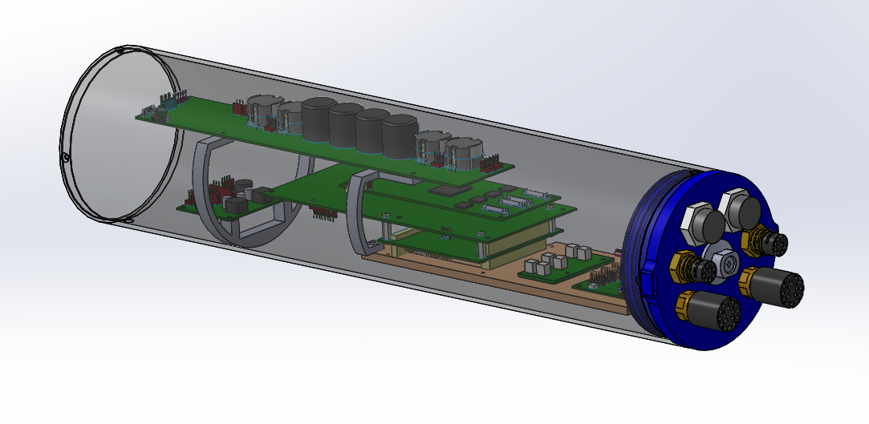

Figure Side-scan Sonar chamber design

**Motors:** The motors used by the platform are Torqeedo Ultralight 403A Pylon motors. These motors are equipped with position sernsors that make sure that if the orientation of the motors is not in the right direction, they'll stop all operations. Means of communication with the motors is by Ethernet (RS485 to USB).

**literature review**

In recent years, there has been an increasing focus on the development of autonomous watercrafts, as they can provide a cost-effective and efficient solution to tasks such as surveying and exploration in shallow marine environments. Autonomous kayaks, equipped with sonar systems, are increasingly being used to explore shallow marine environments due to their low cost, small size, and efficient maneuverability. This literature review seeks to explore recent research and developments in this field.

The WHOI Jetyak [1] is an example of an autonomous kayak with a sonar system that has been used for oceanographic research in shallow or dangerous waters. The Jetyak was designed to be able to autonomously navigate, collect data, and return to a designated dock without any human intervention. It is equipped with an acoustic Doppler current profiler (ADCP) for measuring ocean currents, an inertial navigation system (INS) for navigation and positioning, a single beam echo sounder (SBES) for bathymetric mapping, and an onboard computer for data processing. The Jetyak has been used successfully in a variety of oceanographic research applications such as monitoring currents, assessing fish habitats, and mapping the seafloor.

The Pladypos survey [2] is another example of an autonomous surface vehicle (ASV) equipped with a sonar system that was used to map the seafloor in the coastal environment of Caesarea Maritima, Israel. The Pladypos was designed to be able to autonomously navigate and collect data while avoiding obstacles and maintaining its position within a designated area. It was equipped with an INS for navigation and positioning, a SBES for bathymetric mapping, an acoustic modem for communication with the shore station, and an onboard computer for data processing. The Pladypos was used successfully to map the seafloor in the coastal environment of Caesarea Maritima.

Multi-modal sonar mapping of offshore cable lines with an autonomous surface vehicle [3] is another example of the use of autonomous kayaks with sonar systems for shallow water exploration and mapping applications. This study demonstrated the ability of an autonomous surface vehicle equipped with multiple sonar systems to accurately map offshore cable lines in shallow waters. The study found that the use of multiple sonar systems allowed for more accurate mapping than would have been possible using only one type of sonar system.

The use of autonomous kayaks with sonar systems has several advantages over traditional methods such as boats or divers. Autonomous kayaks are much smaller than boats, making them easier to deploy in shallow waters or tight spaces where larger vessels may not be able to access easily. Additionally, they can be operated remotely or autonomously, which eliminates the need for human operators in hazardous environments or areas with limited access. Autonomous kayaks also require less energy than traditional boats, making them more cost-effective in terms of fuel consumption [4].

However, there are some drawbacks associated with using autonomous kayaks for surveying shallow marine environments. Autonomous kayaks are limited by their size, which means that they cannot carry as much equipment as larger vessels such as boats or ships. Additionally, their range is limited due to their small size and lack of power compared to larger vessels [5]. Furthermore, autonomous kayaks may not be able to access certain areas due to their size or navigational limitations.

There are several different types of sonar systems available for use in an Autonomous Surface Vehicle (ASV). These include single beam, multibeam, chirp, and Synthetic Aperture Sonar (SAS) systems. Single beam sonar systems are the simplest and are typically used for basic depth measurement and obstacle detection. Multibeam systems measure sound waves emitted from multiple angles, providing a more detailed view of the environment. Chirp systems use a frequency-modulated sound wave to measure the environment and can provide higher resolution data. Finally, SAS combines multiple beams and images to create an even higher resolution image. Each system has its own advantages and disadvantages, so the best option for an ASV will depend on the specific requirements of the application.

Single beam sonar is a popular method of bathymetric mapping in shallow marine environments due to its low cost and ease of use. It operates by emitting a single acoustic pulse from a transducer and recording the time it takes for the sound to return from the seafloor. This method has the advantage of being able to cover large areas quickly, but it has the disadvantage of providing only a single point measurement per ping, resulting in lower resolution data. [6]

Synthetic Aperture Sonar (SAS) is a type of sonar system that uses multiple transducers to form an array and generate high-resolution images of the seafloor. It works by emitting a series of acoustic pulses and recording the echoes with multiple receivers. The data is then processed to form an image of the seafloor. SAS systems have the advantage of providing high-resolution images, but they are more expensive and require more processing power than single beam systems. [7]

Chirp sonar is another type of sonar system that uses multiple transducers to emit a continuous frequency-modulated signal. This signal is then received by multiple receivers and processed to form an image of the seafloor. Chirp sonar provides higher resolution than single beam sonar and is less expensive than SAS. It also has the advantage of being able to scan larger areas than SAS in order to create an image. However, chirp sonar requires more complex processing and data analysis than single beam sonar, requires more processing power. [8]

Multibeam sonar is a type of sonar that uses multiple beams to create a three-dimensional image of the seafloor. Multibeam sonar provides higher resolution than single beam or chirp sonar and can scan larger areas than SAS in order to create an image. However, multibeam sonar requires more complex processing and data analysis than single beam or chirp sonar, which makes it more expensive and time consuming. [9]

For this project, Chirp and Multibeam Sonars were chosen due to their mid-price range and high resolution capabilities compared to other types of Sonars such as Single Beam or Synthetic Aperture Sonars (SAS). Chirp Sonars provide higher resolution than Single Beam Sonars while still being relatively inexpensive compared to SAS systems. Multibeam Sonars provide higher resolution than both Single Beam and Chirp Sonars while still being relatively affordable compared to SAS systems. Furthermore, both Chirp and Multibeam Sonars are capable of scanning larger areas than SAS systems in order to create an image, making them ideal for scanning shallow marine environments.[10]

In conclusion, autonomous kayaks, equipped with sonar systems, are quickly becoming a preferred method for surveying shallow marine environments. This is due to their small size, low cost, and the fact that they can be operated remotely or with no physical assistance. Autonomous kayaks offer a number of advantages over traditional methods such as boats or divers, including their ability to access areas which are too shallow for boats and the flexibility to modify their mission parameters. While autonomous kayaks have some drawbacks, such as limited range and payload capacity, they are a great choice for certain applications that require low-cost, remote monitoring or surveying of marine environments. Overall, autonomous kayaks are proving to be an effective, reliable, and cost-efficient tool for a variety of surveying needs.

**Project constraints:**

A project such as this will require a substantial budget and significant human resources. The main constraints will be:

* Mounting of side-scan sonar: The side-scan sonar only operates under certain conditions, one of which is for it to be underwater. Because of the way the sonar operates, it has a certain angle which it covers and should be mounted in a way that maximize that angle.
* Software development: For the platform to run as expected, several software packages and modules would need to be designed and implemented. Modules such as Navigation guidance, Motor controlling and Sonar interfacing would require a large amount of time for a small team.
* Testing: Testing the platform would require a team and a remote location and those can be expensive.

**Project assumptions:**

This project is developed under The Laboratory for Autonomous Robotics (LAR) at Ben Gurion University. It has the benefit of a collaboration with a mechanical team which is needed for such a project. It also has a budget backing it up. Because of this, we assume that any aid needed for the completion of this project will be give, and the constraints will be overcome.

Another assumption is that because this laboratory develops software for multiple platforms, much of the coding work would be modifying existing code to the needs of the platform.

**Project testing proposal:**

The project has a few key tests needed at the development stage:

1. Interfacing with the side-scan sonar and receiving feedback and live data on a remote computer through UDP client/server communication.
2. Testing the communication between the main chamber (which is mounted on the platform) and a remote operator. Testing should be for a steady communication at a distance of 200 meters.
3. Connecting the platform to a Qground based GUI and displaying real-time data from the platform's sensors such as GPS and environmental status.
4. Test the data stream in real world conditions by deploying the system in the field. Giving the platform a scanning mission and seeing it both navigate itself and send reliable real-time data.

**Schedule and work plan:**

**Budget evaluation:**

Human resources and salaries

The project is estimated to take as much as 9 months.

The student doing the projects spends 10 hours of weekly work.

The total amount of student's work is 405 hours.

For the mechanical assignments, a mechanical engineer spends about 5 work hours per month. A total amount of 45 hours.

The adviser Prof. Hugo Guterman spends between 5-6 hours of consultation per month. A total amount of 50 hours.

Equipment

* Side-scan sonar Klein UUV-3500 & waterproof chamber (include cables)
* GPS
* Power supply board & battery
* Kayak platform & Torqeedo engines
* Up board PC
* Ubiquiti Wi-Fi P2P equipment
* Lora P2P equipment

Total budget:

|  |  |  |  |
| --- | --- | --- | --- |
| Expenditure | Hours | Cost per hour | Total amount [NIS] |
| Student salaries | 405 | 50 | 20,250 |
| Mechanical salary | 45 | 120 | 5,400 |
| Advisor salary | 50 | 400 | 20,000 |
| Salary overhead (25%) |  |  | 11,412.5 |
| Equipment |  |  | 50,000 |
| Others |  |  | 1,000 |
| Total budget |  |  | 69,475 |

**Reference:**

[1] P. Kimball et al., "The WHOI Jetyak: An autonomous surface vehicle for oceanographic research in shallow or dangerous waters," 2014 IEEE/OES Autonomous Underwater Vehicles (AUV), 2014, pp. 1-7

[2] A. Vasilijevic et al., "An ASV for coastal underwater archaeology: The Pladypos survey of Caesarea Maritima, Israel," OCEANS 2015 - Genova, 2015, pp. 1-7

[3] Jung, J.; Lee, Y.; Park, J.; Yeu, T.-K. Multi-Modal Sonar Mapping of Offshore Cable Lines with an Autonomous Surface Vehicle. J. Mar. Sci. Eng. 2022, 10, 361.

[4] <https://journals.plos.org/plosone/article?id=10.1371/journal.pone.0128948>

[5] González-Reolid, I.; Molina-Molina, J.C.; Guerrero-González, A.; Ortiz, F.J.; Alonso, D. An Autonomous Solar-Powered Marine Robotic Observatory for Permanent Monitoring of Large Areas of Shallow Water. Sensors 2018, 18, 3497.

[6] L. Y. S. Chiu et al., “Estimating Geoacoustic Properties of Surficial Sediments in the North Mien-Hua Canyon Region With a Chirp Sonar Profiler” IEEE Journal of Oceanic Engineering vol 40 no 1 pp 222-236 Jan 2015

[7] X Zhang et al., “An Imaging Algorithm for Multireceiver Synthetic Aperture Sonar” Remote Sensing vol 11 no 6 p 672 Mar 2019

[8] Baradello L., “An improved processing sequence for uncorrelated Chirp sonar data” Mar Geophys Res 35 pp 337–344 2014

[9] Schimel A C G et al., “Multibeam sonar backscatter data processing” Mar Geophys Res 39 pp 121–137 2018

[10] D P Williams “Underwater target classification in synthetic aperture sonar imagery using deep convolutional neural networks” 2016 23rd International Conference on Pattern Recognition (ICPR) pp 2497-2502 2016

**המלצת ציון (ע"י מנחה אקדמי) לדו"ח מכין**

אם יש צורך, לכל סטודנט/ית בנפרד

מספר הפרויקט: _____-____20-P

שם הפרויקט:

שם המנחה החיצוני:

שם המנחה מהמחלקה:

שם הסטודנט/ית: ת.ז.:

|  |  |  |  |  |  |  |  |
| --- | --- | --- | --- | --- | --- | --- | --- |
| % |  | חלש  55-64 | בינוני  65-74 | טוב  75-84 | ט"מ  85-94 | מצוין  95-100 |  |
| 15 | הבנת הנושא הצורך וסביבת היישום |  |  |  |  |  |  |
| 15 | חיפוש מקורות והבנת עבודות דומות |  |  |  |  |  |  |
| 15 | שלמות דף מפרט (הצעת מחקר) |  |  |  |  |  |  |
| 15 | הצעת תכנון ותכנון הבדיקות הסופיות |  |  |  |  |  |  |
| 10 | גילוי יוזמה וחריצות |  |  |  |  |  |  |
| 20 | פתרון בעיות, מקוריות ותרומה אישית  (מעבר למילוי ההנחיות) |  |  |  |  |  |  |
| 10 | הערכת תקציב, לו"ז וחלוקת עבודה,  ציון מקורות ושלמות כללית |  |  |  |  |  |  |

הערכת רמת הקושי של הפרויקט: קל מאוד / קל / בינוני / קשה / קשה מאוד

הערות: